Curriculum Vitae (C.V.)
- Personal data:
Name (Arabic) | إسراء أشرف محمد عبدالحليم يوسف
Name (English) | Esraa Ashraf Mohammed AbdElhalim Youssef
Department | Medical biochemistry and molecular biology
College | Benha faculty of medicine
Academic degree | Assistant Lecturer
Office Address
Mobile 1 | 01004214758
Home phone | 0133105864
Work phone
Fax
Email (university) | esraa.ashraf@fmed.bu.edu.eg
Email (alternative) | eesraaaashraf@gmail.com
Web site (if any)
Recent Photo (passport format) | 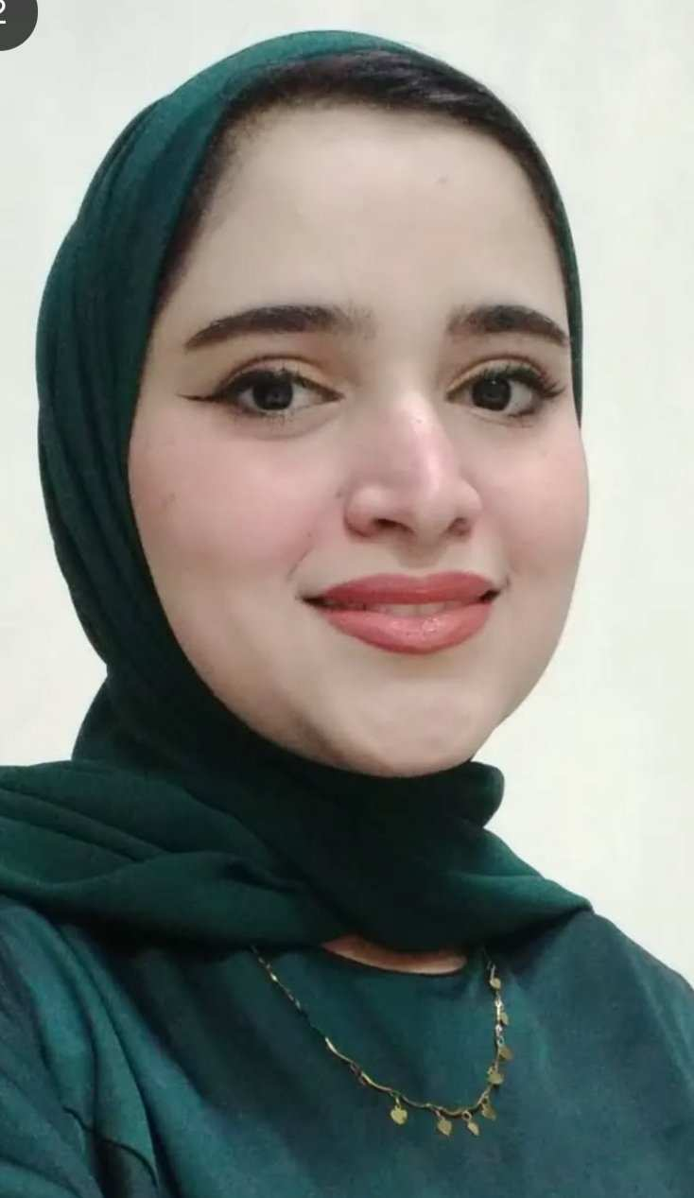
- Education:
2.A. Degree obtained;
Institution | Degree obtained | Year
Benha faculty of medicine | Bachelor of medicine and surgery | 2020
Benha faculty of medicine | M.Sc. in Basic Medical Sciences (Medical Biochemistry) | 2025

2.B. Specialty;
General specialty. | Medical Biochemistry and Molecular Biology
Specific specialty. | Medical Biochemistry and Molecular Biology

2.C. Language skills (Excellent, Very Good, Good or Basic);
Language | Reading | Speaking | Writing
Arabic. | excellent | excellent | excellent
English. | excellent | Very good | excellent
French.
Other (specify).

- Positions:
Tittle | Year | University/Institution
Demonstrator | 2022 | Benha faculty of medicine
Assistant Lecturer | 2025 | Benha faculty of medicine

- Cooperation with local and international entities having website:
( جامعة – مؤسسة - وزارة – مركز بحثي – عضو هيئة تدريس – باحث - شركة – مصنع – الخ)
Name of local and international entity | Website
- Membership of professional bodies (List):

- Membership of institute (List):

- Distinction and Awards (List):

- Academic:
Courses at under graduate level;
1. Course name: | Clinical rounds;
2. Course name: | Lectures;
Courses at post graduate level;
1. Course name: | Clinical rounds;
2. Course name: | Lectures;
- Areas of research:

- PhD/M.Sc Supervision:
Title | PhD/M.Sc | Year completed / in progress

- Grants for Projects:
Funding organization | Project title | Role | Year
- Committees:

- List of Publications:
MicroRNA-155 expression and Endothelial Nitric Oxide Synthase (eNOS)gene variants in Egyptian patients with preeclampsia

14. Attended Workshops, Symposiums, and Conferences: "List name and year";

Name of Workshops, Symposiums, and Conferences | Year
10th Annual Medical Conference | 2023  Benha University, Biochemistry Department | 2023
11th Annual Medical Conference | 2024  Benha University, Biochemistry Department | 2024
4th Annual Conference of posts gradute studies (APPLIED SCIENCES) | 2025 | 2025
12th Annual Medical Conference | 2025  Benha University, Biochemistry Department | 2025
PCR workshop | 2024

- Books published:

16. Positions:
 | Date | Organization | Country | Position
1
2
3

17. Activities in faculty/university/community service:
Name of Activity service | Year
- Teaching :(Rounds and lectures). taught practical biochemistry sessions to first, second and third year medical students. | 2023-2025
- Clinical meeting.
- Making conferences.
- Medical Convoys.
- Workshops.
18. Consulting Experience (if any):

19. Additional information you would like to put on the website:

